In Lice, Clues to Human Origin and Attire (from the NY Times)
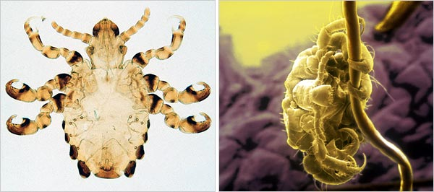
Left, The Natural History Museum, London; right, Mona Lisa Productions/Photo Researchers
Scientists believe they have figured out how and why the human pubic louse, right, and the gorilla louse, left, diverged 3.3 million years ago.

By NICHOLAS WADE Published: March 8, 2007

One of the more embarrassing mysteries of human evolution is that people are host to no fewer than three kinds of louse while most species have just one. Even bleaker for the human reputation, the pubic louse, which gets its dates and residence-swapping opportunities when its hosts are locked in intimate embrace, does not seem to be a true native of the human body. Its closest relative is the gorilla louse. (Don’t even think about it.)

Louse specialists now seem at last to have solved the question of how people came by their superabundance of fellow travelers. And in doing so they have shed light on the two major turning points in the history of fashion: when people lost their body hair, and when they first made clothing.
Three kinds of louse call Homo sapiens their home, but each occupies a different niche on the human body. The head louse, Pediculus humanus, lives in the forest of fine hairs on the scalp. Its cousin, the body louse, lives not on the skin but in clothes. And the exclusive territory of the pubic louse, Phthirus pubis, is the coarser hairs of the crotch.

Lice are intimately adapted to their hosts and cannot long survive away from the body’s blood and warmth. If their host evolves into two species, the lice will do likewise. So biologists have long been puzzled over the fact that the human head louse is a sister species to the chimpanzee louse, but the pubic louse is closely related to the gorilla louse.

By comparing louse DNA, a team led by David L. Reed of the University of Florida has now reconstructed how this strange situation probably came about. Dr. Reed’s team collected pubic lice from a public health clinic in Salt Lake City. Samples of gorilla lice were obtained by members of the Mountain Gorilla Veterinary Project, which provides free health care to gorillas in the wild.

The number of DNA differences between the gorilla louse and the pubic louse indicates that they diverged some 3.3 million years ago, Dr. Reed and colleagues report in today’s issue of the journal Biomed Central Biology. Among people, the pubic louse is usually spread by sexual contact, but the gorilla louse could have been contracted in some other way.

“We’ll never know if it was sex or something more tame,” Dr. Reed said. What can be said about the transfer, he believes, is that it signals human ancestors had already lost their body hair by 3.3 million years ago, confining the human louse to the head and leaving the groin open to invasion by the gorilla louse.

Archaeologists contend that human ancestors lost their standard ape body hair when they left the shade of the forests for the hot, open savanna and needed bare skin for efficient sweating. Adaptation to the savanna was well in place by 1.7 million years ago. But loss of body hair could have begun earlier, and Dr. Reed’s result suggests a time for when people first became naked.

If people first became nudists 3.3 million years ago, when did they start to wear clothes? Surprisingly, lice once again furnish the answer. Though humans may long have worn loose garments like animal skin cloaks, the first tailored clothing would have been close-fitting enough to tempt the head louse to expand its territory. It evolved a new variety, the body louse, with claws adapted for clinging to fabric, not hairs.
In 2003, Mark Stoneking, a geneticist at the Max Planck Institute in Leipzig, Germany, estimated from DNA differences that the body louse evolved from the head louse about 107,000 years ago. The first sewn clothes were presumably made shortly before this time.

Probing back even earlier in louse evolution, Dr. Reed and his colleagues report that the two species of primate lice, Pediculus and Phthirus, probably diverged from each other on an ape host 13 million years ago. The divergence may have happened after the lice started to specialize in different parts of the body.
Some seven million years ago, this ancient ape species split into gorillas and the ancestors of humans and chimps, with both lineages infected by both species of lice. But Pediculus then fell extinct in its gorilla hosts, according to Dr. Reed’s reconstruction, and Phthirus vanished from the chimp-human ancestor. Next, chimps and humans diverged, and their joint louse diverged with them into Pediculus humanus and Pediculus schaeffi. The last event in this history of human-louse cohabitation was the transfer of the gorilla’s Phthirus louse to people. Dr. Stoneking said Dr. Reed’s reconstruction was “pretty reasonable” and said he agreed that acquisition of the gorilla’s louse indicated people had lost their body hair by then. “The transfer doesn’t have to be sexual,” he said, “but presumably it does require reasonably close contact.”

